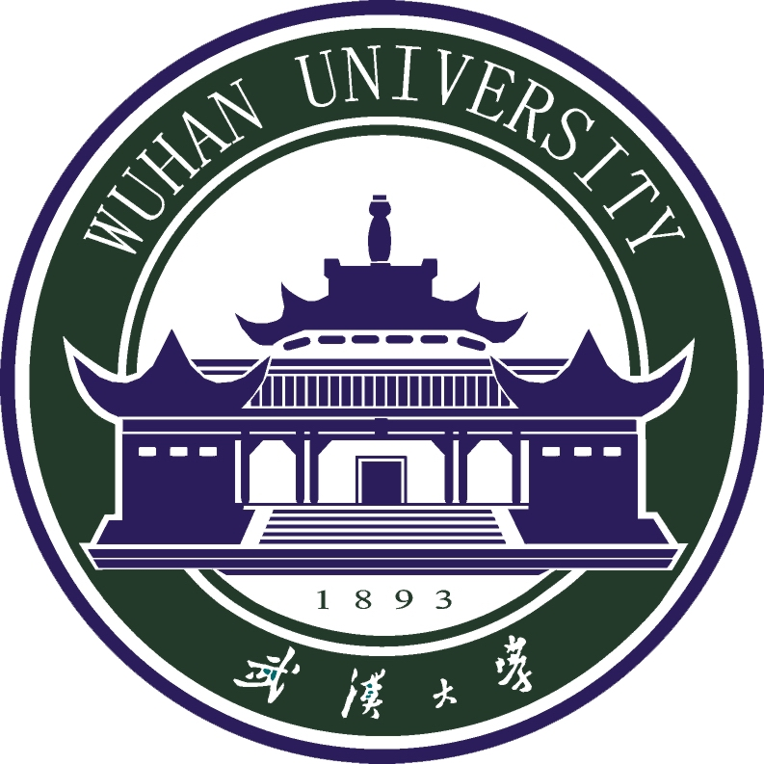

2019
Luojia International Summer Program
珞珈国际夏令营
June 23rd - July 10th
6月23日——7月10日

2019珞珈国际夏令营行程表

6.23-6.29 |  | 6.23(日) | 6.24(一) | 6.25(二) | 6.26(三) | 6.27(四) | 6.28(五) | 6.29(六)
第一周 | 上午(9:00-12:00) | 接机&入住 | 开营仪式&  校园参观 | 专题讲座：  中国外交1 | 专题讲座：  中国外交2 | 专题讲座：  跨文化传播1 | 汉语入门 | 专题讲座：  跨文化传播2
 | 下午 (14:00-17:00) |  | 夏令营联欢会 | 文化体验：  太极1 | 文化体验：  太极2 | 汉语入门 | 文化体验：  参观湖北省  博物馆 | 专题讲座：  中国经济1
 | 晚上  (18:30-21:30) |  |  |  |  |  | 文化体验：  知音号
6.30-7.06 |  | 6.30(日) | 7.01(一) | 7.02(二) | 7.03(三) | 7.04(四) | 7.05(五) | 7.06(六)
第二周 | 上午 (9:00-12:00) | 专题讲座：  中国历史1 | 专题讲座：  中国历史2 | 专题讲座：  中国政治1 | 专题讲座：  中国政治2 | 武汉—杭州 | 访问浙江大学 | 文化体验：  游览西湖风景  名胜区
 | 下午 (14:00-17:00) | 专题讲座：  中国经济2 | 文化体验：  参观黄鹤楼 | 专题讲座：  中国宗教与宗教艺术 | 专题讲座：  中国民俗文化 | 文化体验：  游览清河坊
7.07-7.10 |  | 7.07(日) | 7.08(一) | 7.09(二) | 7.10(三) | 7.11(四) | 7.12(五) | 7.13(六)
第三周 | 上午 (9:00-12:00) | 文化体验：  雷峰塔 | 专题讲座：  中国法律1 | 专题讲座：  中国法律2 | 返程
 | 下午 (14:00-17:00) | 杭州—武汉 | 文化体验：  中国画 | 闭幕式
*行程安排或因天气原因与意外情况有所调整。

2019 Luojia International Summer Program

6.23-6.29 |  | Sun. | Mon. | Tue. | Wed. | Thur. | Fri. | Sat.
The First Week | Morning (9:00-12:00) | Airport pick-up & dormitory check-in | Opening Ceremony & Campus Tour | Seminar:  Chinese Diplomacy 1 | Seminar:  Chinese Diplomacy2 | Seminar: Transcultural Communication 1 | Chinese Language Course 2 | Seminar: Transcultural Communication 2
 | Afternoon (14:00-17:00) |  | Ice-Breaking Party | Culture experience: Tai Chi | Culture experience: Tai Chi | Chinese Language Course 1 | Culture experience:  Hubei Provincial Museum | Seminar:  Chinese Economy 1
 | Evening  (18:30-21:30) |  |  |  |  |  | Culture experience:  Yangtze River Cruise
6.30-7.06 |  | Sun. | Mon. | Tue. | Wed. | Thur. | Fri. | Sat.
The Second Week | Morning (9:00-12:00) | Seminar:  Chinese History 1 | Seminar:  Chinese History 2 | Seminar:  Chinese Politics 1 | Seminar:  Chinese Politics 2 | Go to Hangzhou city | Visit to Zhejiang University | Culture experience:  West Lake Cultural Landscape of Hangzhou
 | Afternoon (14:00-17:00) | Seminar:  Chinese Economy 2 | Culture experience: Yellow Crane Tower | Seminar:  Chinese Religions and Religious Arts | Seminar:  Chinese Folklore and Culture | Culture experience: Qinghefang Ancient Street
7.07-7.10 |  | Sun. | Mon. | Tue. | Wed. | Thur. | Fri. | Sat.
The Third Week | Morning (9:00-12:00) | Culture experience:  Leifeng Pagoda | Seminar:  Chinese Legal System 1 | Seminar:  Chinese Legal System 2 | Departure
 | Afternoon (14:00-17:00) | Back to Wuhan | Culture experience: Chinese Painting  Course | Closing Ceremony
*Courses and other activities are subject to change.
*Student can join half or a portion of the program if their holiday time is different with our schedule.

